
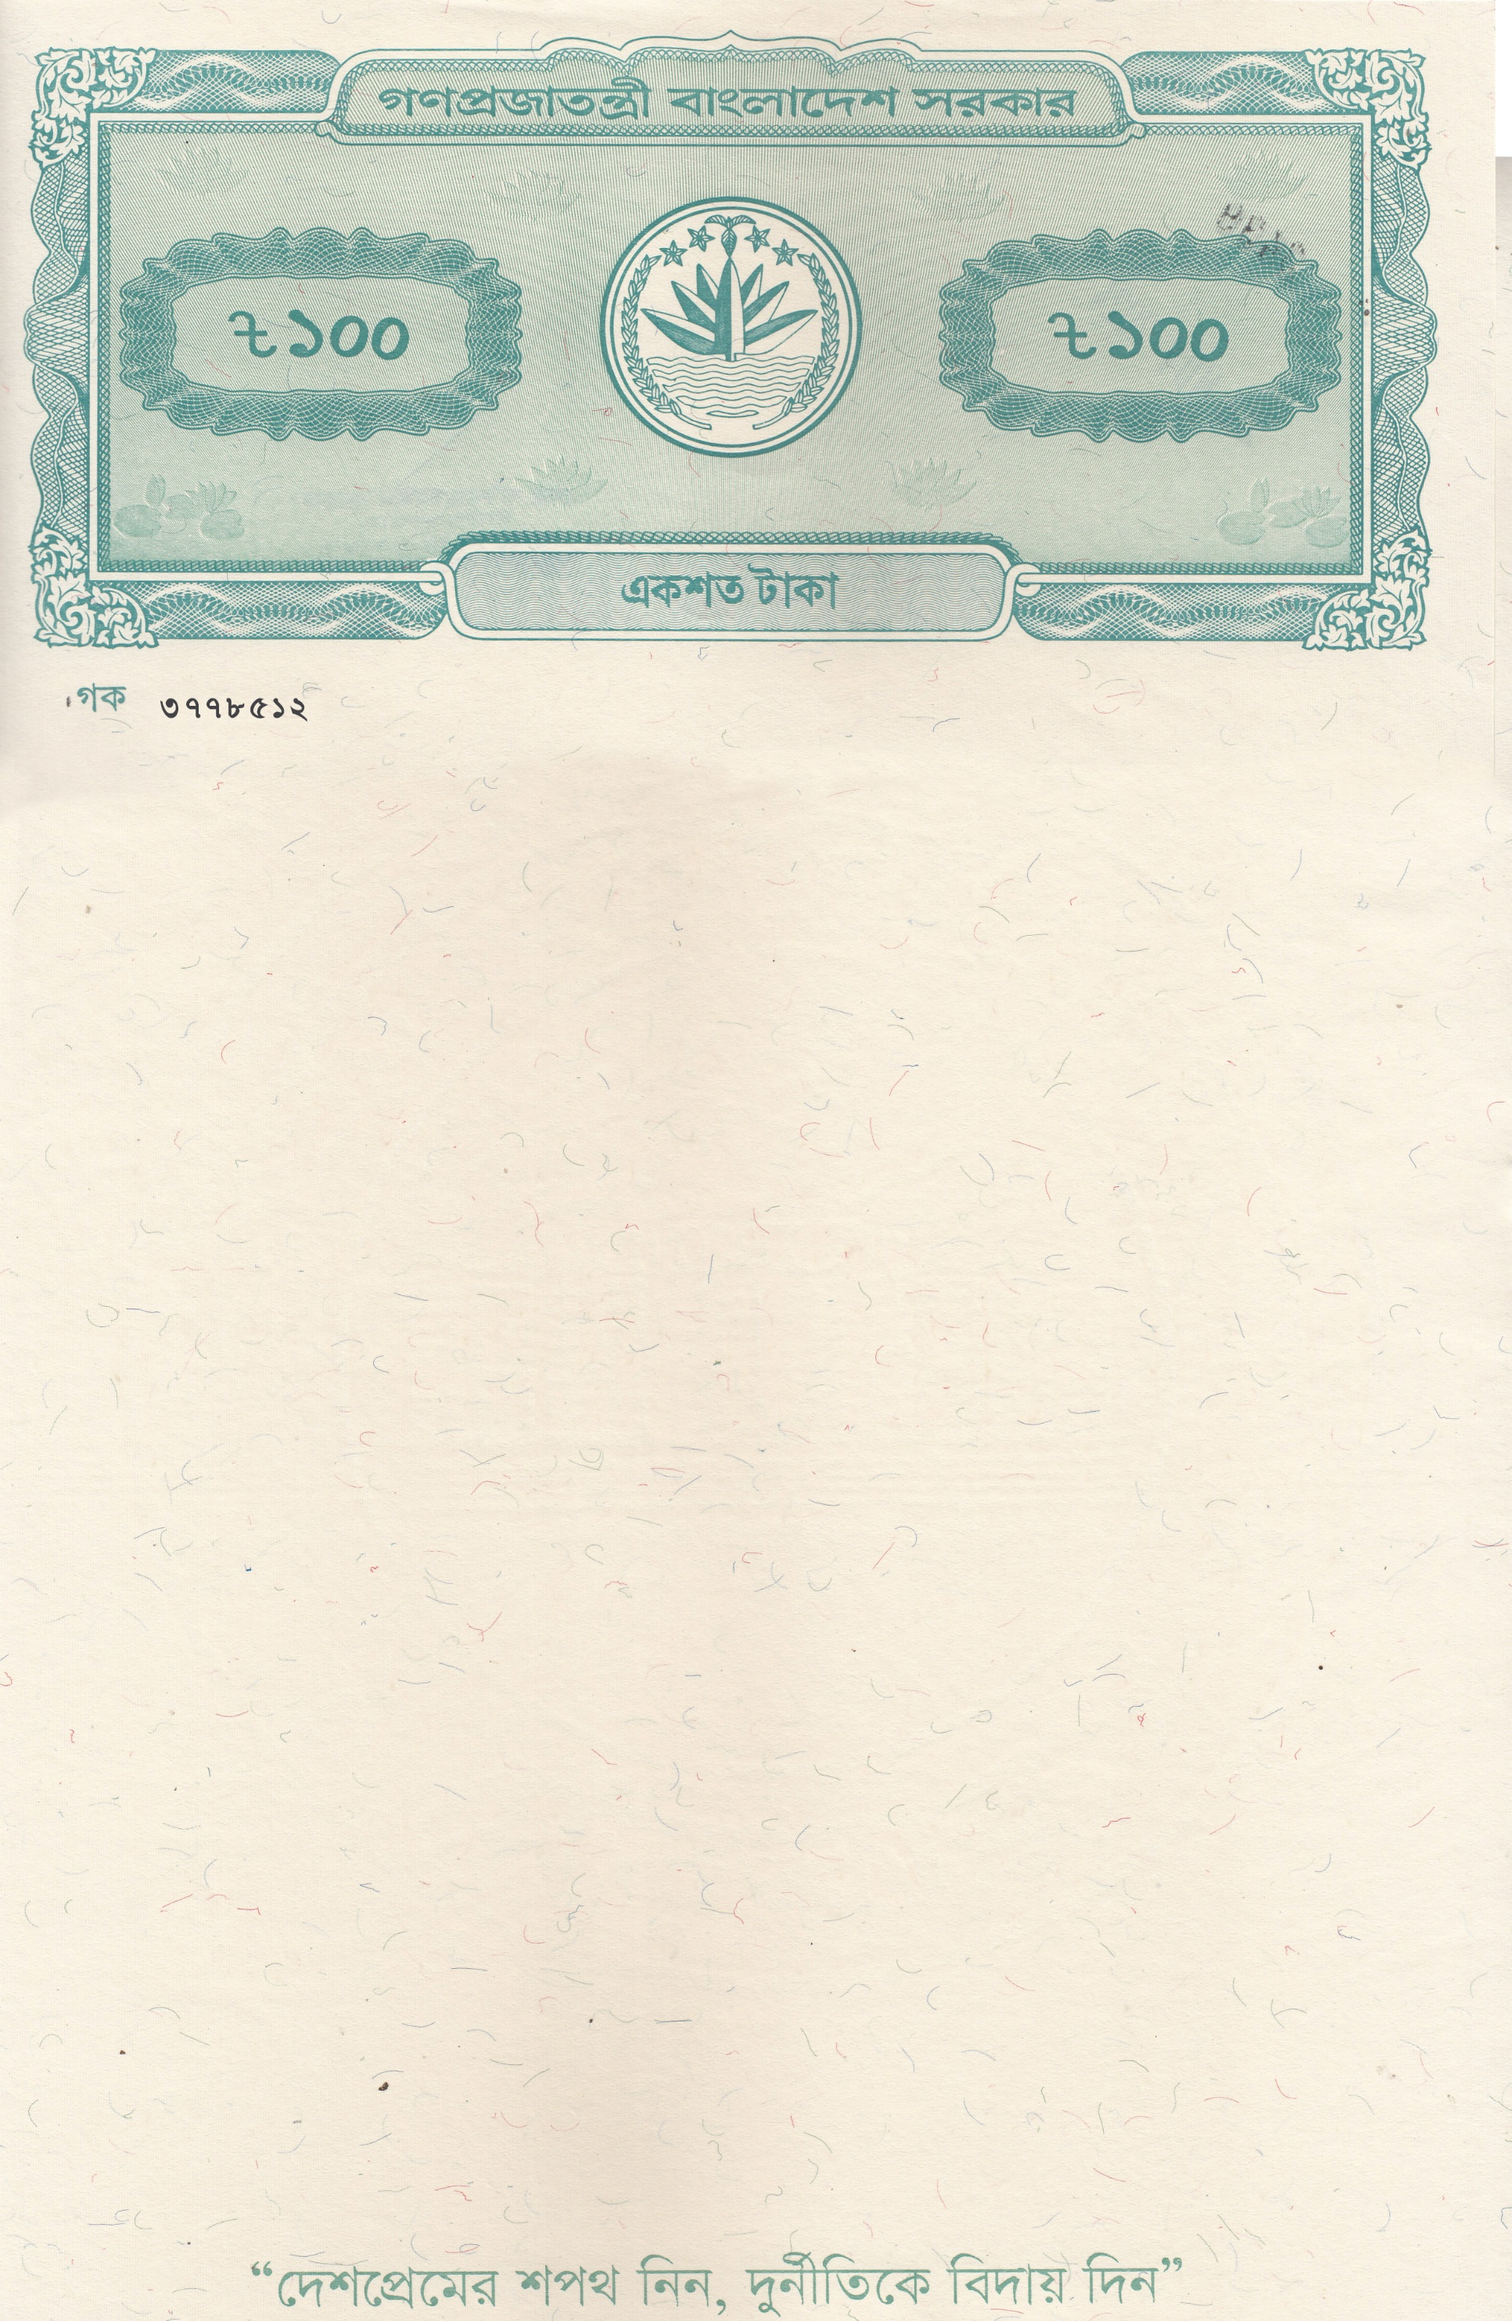
The Notary Public Dhaka, Bangladesh
AFFIDAVIT
(Regarding To My Business Transaction by cash)
I, Mary Margaret Costa, Father’s Name: Michael Rosario, Mother’s Name: Cecilia Rodrigues, Permanent Address: House/Holding: 16/C, Village/Road: East Rajabazar, Post Office: Tejgaon - 1215, Tejgaon, Dhaka North City Corporation, Dhaka. Nationality: Bangladeshi, National ID Card No- 8227341917, Religion: Christian, Profession: Business, do hereby solemnly affirm and declare the following that:

- That I am a Permanent citizen of Bangladesh and a Bangladeshi national by birth.

- That I am the lawful "Sponsor" and "Guarantor" of my son (MATHEW MICKEY COSTA) who is intended to study in Australia.

- That I declare through this Affidavit that I am a business man from long time and conduct a business named MICKEY COSTA COLLECTION at Abdullahpur Jame Masjid Songlogno, Nama Para, Sector-9, Uttara, Dhaka. Then Monthly I get regular Income of Business BDT 240,000.00 (Two Lac Forty Thousand) Taka only from my mentioned business on average and as a result, Yearly Income is BDT. 2,880,000.00 (Twenty Eight Lac Eighty Thousand) Taka only in average. To be Proof, I am attaching some documents with this affidavit.

- As my business is Wholesaler & Retailer of Readymade Garments and I have average Local customer due to business nature, So, I have to make cash transaction for many reasons and nature of business but I don't need to open any Bank Account for my mentioned Business and I always make business transaction personally through cash.

I like to inform for your acknowledgement that I do not need to open any bank Account for business purposes due to the nature of business.

- That this affidavit shown by me as a piece of documentary evidence in support of my regular cash transaction in my Business that are mentioned above and this affidavit shall be submitted before the authority concern if and when required.
That the statements made herein above are true to the best of my
Knowledge and belief and I swear and sign this affidavit today on
30/04/2026 AD.
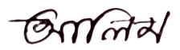


Deponent Signature
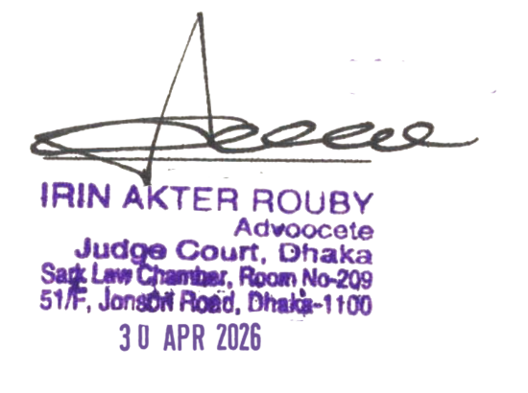

The deponent is identified by me and He has signed in my presence.

